Begin Core & Pelvic Floor Healing Exercises

Knee squeezes

- Lie on your back knees bent feet flat
- Place a ball or pillow between your knees
- Toes turned in slightly & feet 4 to 5 inches apart
- Arms down to the sides palms facing up
- Inhale through your nose into your back + sides + front 360º
  - Relax pelvic floor
- Exhale slowly like fogging a mirror
  - Squeeze the ball
  - Gently lift pelvic floor up inside
  - Feel ribs drop because of full exhale

Hooklying Arm Glides
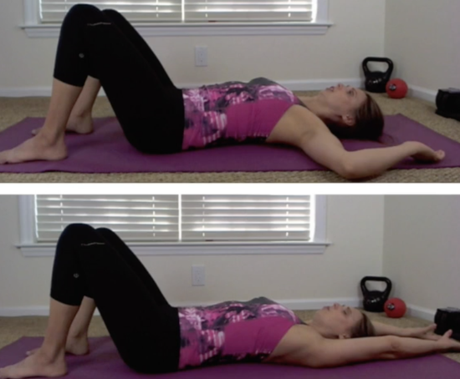
- Lie on your back knees bent feet flat
- Rest your arms in a goal post position with backs of hands on the floor and elbows on the floor
- Inhale: back, sides and abdomen and pelvic floor relaxes.
  - Feel the pressure go down to pelvic floor feeling it relax
- Exhale: bring lower belly in
  - engage pelvic floor
    - ribs pull down
    - slide up with arms don’t let back arch way up off floor

Hand/Leg Opposite Lifts
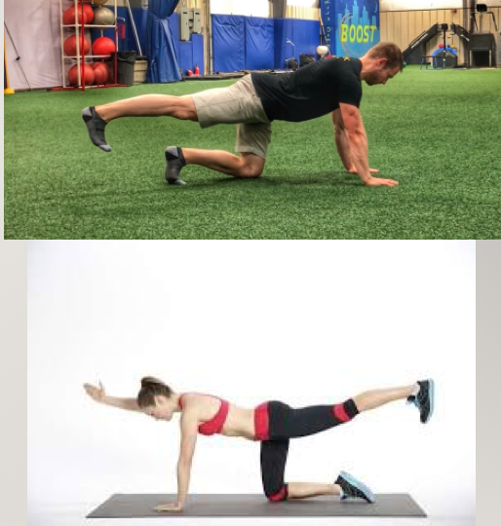
- Kneel with knees directly below hips and wrists directly below shoulders
- Exhale drawing abdomen toward the spine as you push the left leg / heel straight back and reach right arm out in front of you – HOLD FOR FULL EXHALE ( you can just do legs if you feel imbalance doing arm & leg)
- Inhale as you have all 4’s on ground again
- Alternate sides

